[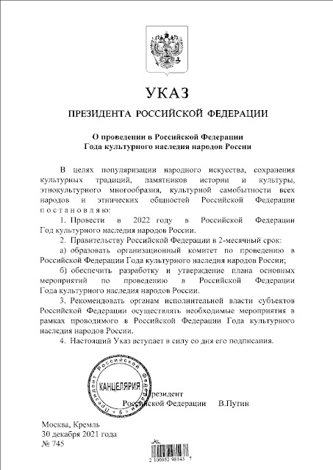](https://blogger.googleusercontent.com/img/a/AVvXsEgmAKOREzwCRom_4_M4hBQpAD3stIHmYLtk8wBYdJHLaY5l2SmtQVbTKgavv9UeyiOJCPWo-uoEkUYVAlDb5Z-NhIGukr85m8owiIgUyQpS6bp1nLIILU_5YOCZ0pPEl48asOQir6wGsywaUv0aGHfilg4W3PS3biOCDS8YzRWPSa-AyjMSob7vFMb8=s905)